# Programming Technologies

Technical details will be discussed in this chapter. It will be divided into two main parts: front-end and back-end.

## Front-end Technologies

### JavaScript and Ajax

Many modern approaches were used for our project development. We used JavaScript and Ajax for most interactive content in HTML pages. For example, the search recommendation division used Ajax so that the search results can be shown on visitors’ browsers without redirecting to search result page. This would highly improve the experience of users and they can choose the stock they want without input the name or symbol completely. JavaScript is used for most form. This would help to create an interactive content where users can send request as their wishes to the server but get the content neglecting their demands. For example, they can add or remove stock from their personal stock list after log in, so they do not need to search for stocks they want to track each time. They can also request data and charts between any time interval as they may want.

Several technologies derived from JavaScript are also used including JSON and jQuery. These technologies simplify the development and maintenance of the website. JSON is a language-independent data format. It derives from JavaScript, but as of 2016, code to generate and parse JSON-format data is available in many programming languages. It provides the extendibility for further application might run on the system. jQuery is a cross-platform JavaScript library designed to simplify the client-side scripting of HTML. jQuery is the most popular JavaScript library in use today, with installation on 65% of the top 10 million highest-trafficked sites on the Web.

### HTML5

Besides, the design of our pages meets HTML5 standards, which can enhance the user experience and make it more stable and compatible. We also used CSS3 for our UI design and every page is fluid-gridded, which means no matter what and how large the devices are and how much resolution the screens have, the pages will be displayed correctly and friendly on their devices. The users will never see a single page with too small front when they want to track their stocks with their cellphones on the way home.

### PHP

PHP is a server-side scripting language designed for web development but also used as a general-purpose programming language. Every page was generated by PHP, which means it can change dynamically when requested. And with PHP, a user management system and admin system were also implemented so each user can manage their own stock list and more functions can be extended conveniently. The admin system can add or remove stocks globally, both prediction algorithms and data collection function will be adjusted according to the system stocks lists stored also in database automatically. Once the system was deployed, everything maintenance will have friendly UI so the maintenance can be achieved by administrator without programming technologies.

### PaaS

The whole website is deployed on a cloud computing PaaS platform provided by RedHat Company with resources of Amazon. It can be extended to support millions of requests per second. Platform as a service (PaaS) is a cloud computing model that delivers applications over the Internet. In a PaaS model, a cloud provider delivers hardware and software tools -- usually those needed for application development -- to its users as a service. A PaaS provider hosts the hardware and software on its own infrastructure.

### CDN

To help visitors have faster access to the website, and to reduce the pressure of the server, CDN was used for our website. Here is the ping time from my computer to the original server provided by Amazon AWS:

|  |
| --- |
| PING ec2-54-85-48-36.compute-1.amazonaws.com (54.85.48.36): 56 data bytes  64 bytes from 54.85.48.36: icmp_seq=0 ttl=42 time=23.087 ms  64 bytes from 54.85.48.36: icmp_seq=1 ttl=42 time=22.981 ms  64 bytes from 54.85.48.36: icmp_seq=2 ttl=42 time=10.726 ms  64 bytes from 54.85.48.36: icmp_seq=3 ttl=42 time=9.327 ms  64 bytes from 54.85.48.36: icmp_seq=4 ttl=42 time=10.692 ms  64 bytes from 54.85.48.36: icmp_seq=5 ttl=42 time=9.534 ms  64 bytes from 54.85.48.36: icmp_seq=6 ttl=42 time=10.733 ms  64 bytes from 54.85.48.36: icmp_seq=7 ttl=42 time=11.720 ms  64 bytes from 54.85.48.36: icmp_seq=8 ttl=42 time=12.662 ms  64 bytes from 54.85.48.36: icmp_seq=9 ttl=42 time=11.102 ms  ^C  --- ec2-54-85-48-36.compute-1.amazonaws.com ping statistics ---  10 packets transmitted, 10 packets received, 0.0% packet loss  round-trip min/avg/max/stddev = 9.327/13.256/23.087/4.972 ms |

Where we can see the that the average ping time is 13.256 ms even though the server is physically located in East America. Here is the the result of ping time via CDN:

|  |
| --- |
| PING se2cdn.peterjiang.me (104.28.7.117): 56 data bytes  64 bytes from 104.28.7.117: icmp_seq=0 ttl=53 time=9.910 ms  64 bytes from 104.28.7.117: icmp_seq=1 ttl=53 time=9.631 ms  64 bytes from 104.28.7.117: icmp_seq=2 ttl=53 time=10.458 ms  64 bytes from 104.28.7.117: icmp_seq=3 ttl=53 time=8.728 ms  64 bytes from 104.28.7.117: icmp_seq=4 ttl=53 time=9.780 ms  64 bytes from 104.28.7.117: icmp_seq=5 ttl=53 time=9.832 ms  64 bytes from 104.28.7.117: icmp_seq=6 ttl=53 time=15.039 ms  64 bytes from 104.28.7.117: icmp_seq=7 ttl=53 time=8.891 ms  64 bytes from 104.28.7.117: icmp_seq=8 ttl=53 time=8.360 ms  64 bytes from 104.28.7.117: icmp_seq=9 ttl=53 time=9.488 ms  64 bytes from 104.28.7.117: icmp_seq=10 ttl=53 time=8.335 ms  ^C  --- se2cdn.peterjiang.me ping statistics ---  11 packets transmitted, 11 packets received, 0.0% packet loss  round-trip min/avg/max/stddev = 8.335/9.859/15.039/1.763 ms |

The average ping time is just 9.859 ms which is dramatically dropped and the longest ping time is 15.039 ms, which is just slightly more than the average time without CDN. The difference will be even more if the clients visit the website from a longer distance for example in the other side of the country or earth.

A content delivery network (CDN) is a system of distributed servers (network) that deliver webpages and other Web content to a user based on the geographic locations of the user, the origin of the webpage and a content delivery server.

### HTTPS

Another measure used on our website is HTTP over TLS, or more widely known as HTTPS. It ensures the sensitive information of users, such as emails, password and the stocks users tracking, will be protected properly and the communication between clients and servers will not be acquired without authority. The website is globally protected by HTTPS with SHA-256, which is also used by Wikipedia, Chase and TOR. Any content without proper encryption will not be transferred to and from users.

In its popular deployment on the internet, HTTPS provides authentication of the website and associated web server with which one is communicating, which protects against man-in-the-middle attacks. Additionally, it provides bidirectional encryption of communications between a client and server, which protects against eavesdropping and tampering with and/or forging the contents of the communication. In practice, this provides a reasonable guarantee that one is communicating with precisely the website that one intended to communicate with (as opposed to an impostor), as well as ensuring that the contents of communications between the user and site cannot be read or forged by any third party.

### Google Visualization

With the help with Google Visualization, which is a widely used and mature API provided by Google, plotting charts is efficiently more than ever. The chart as follows can be created without using much resource of the server.

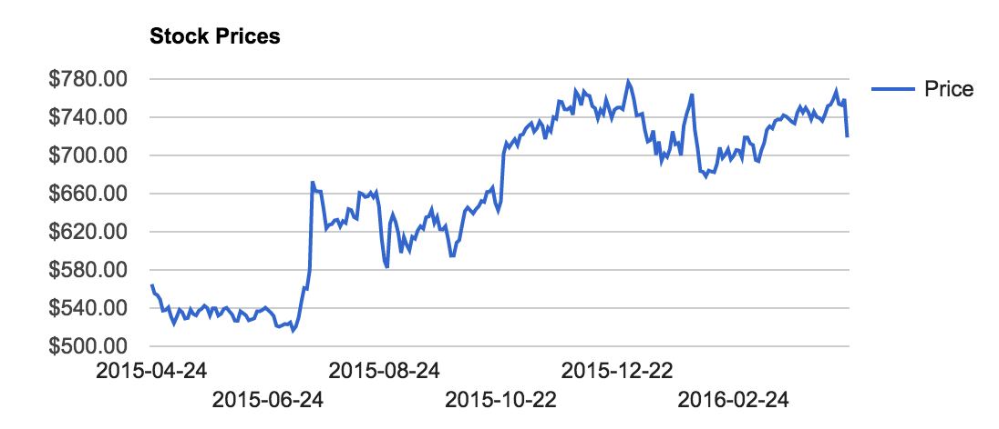

## Back-end Technologies

### MATLAB

Most of the algorithms were implemented with Matlab, which provides fast and stable performance for calculation. No matter how complicated the algorithms are, Matlab can calculate and write the result into database fast and stable. It ensures the core of the website functions well.

### MySQL

The most important part of the website is the database, which was implemented with MySQL. It ensures all the data can be stored and retrieved conveniently and all of the components and applications can be integrated together easily. MySQL is an open-source relational database management system (RDBMS); in July 2013, it was the world's second most widely used RDBMS, and the most widely used open-source client–server model RDBMS. The structure of the database used is discussed in other chapter.